1. Permissions on `/etc/shadow` should allow only `root` read and write access.

- Command to inspect permissions:

ls -l /etc/shadow

- Command to set permissions (if needed):

sudo chmod 600 /etc/shadow

2. Permissions on `/etc/gshadow` should allow only `root` read and write access.

- Command to inspect permissions:

ls -l /etc/gshadow

- Command to set permissions (if needed):

sudo chmod 600 /etc/gshadow

3. Permissions on `/etc/group` should allow `root` read and write access, and allow everyone else read access only.

- Command to inspect permissions:

ls -l /etc/group

- Command to set permissions (if needed):

sudo chmod 644 /etc/group

4. Permissions on `/etc/passwd` should allow `root` read and write access, and allow everyone else read access only.

- Command to inspect permissions:

ls -l /etc/passwd

- Command to set permissions (if needed):

sudo chmod 644 /etc/passwd

**### Step 2: Create User Accounts**

1. Add user accounts for `sam`, `joe`, `amy`, `sara`, and `admin`.

- Command to add each user account (include all five users):

sudo useradd sam

sudo useradd joe

sudo useradd amy

sudo useradd sara

sudo useradd admin

2. Ensure that only the `admin` has general sudo access.

- Command to add `admin` to the `sudo` group:

sudo usermod -a -G sudo admin

**### Step 3: Create User Group and Collaborative Folder**

1. Add an `engineers` group to the system.

- Command to add group:

sudo addgroup engineers

2. Add users `sam`, `joe`, `amy`, and `sara` to the managed group.

- Command to add users to `engineers` group (include all four users):

sudo usermod -a -G engineers sam

sudo usermod -a -G engineers joe

sudo usermod -a -G engineers amy

sudo usermod -a -G engineers sara

3. Create a shared folder for this group at `/home/engineers`.

- Command to create the shared folder:

mkdir /home/engineers

4. Change ownership on the new engineers' shared folder to the `engineers` group.

- Command to change ownership of engineer's shared folder to engineer group:

sudo chgrp engineers /home/engineers

sudo chmod 2775 /home/engineers

**### Step 4: Lynis Auditing**

1. Command to install Lynis:

sudo apt install lynis

2. Command to see documentation and instructions:

man lynis

3. Command to run an audit:

sudo lynis audit system

4. Provide a report from the Lynis output on what can be done to harden the system.

- Screenshot of report output:

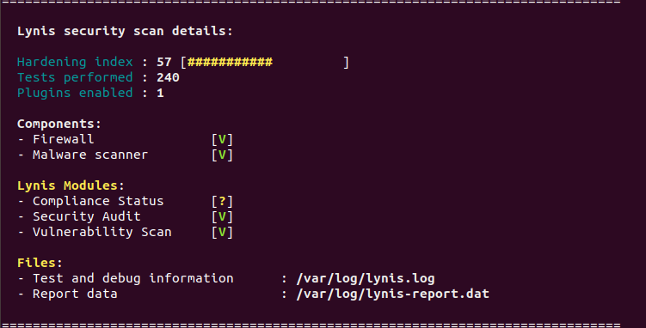

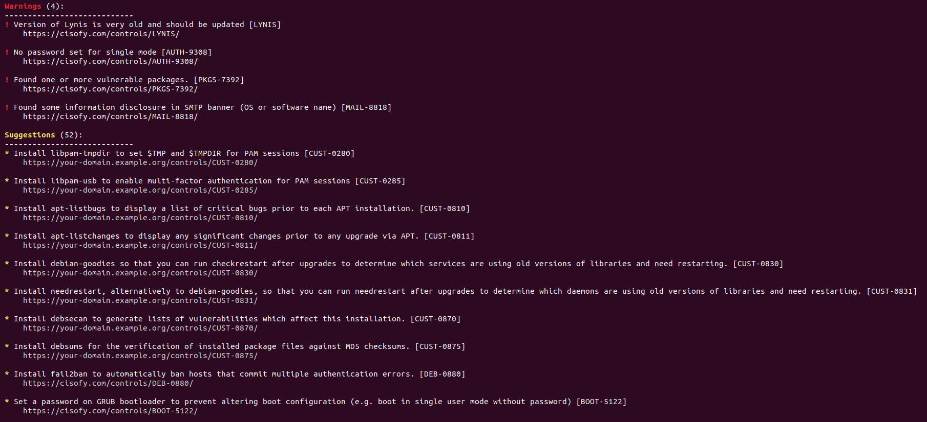

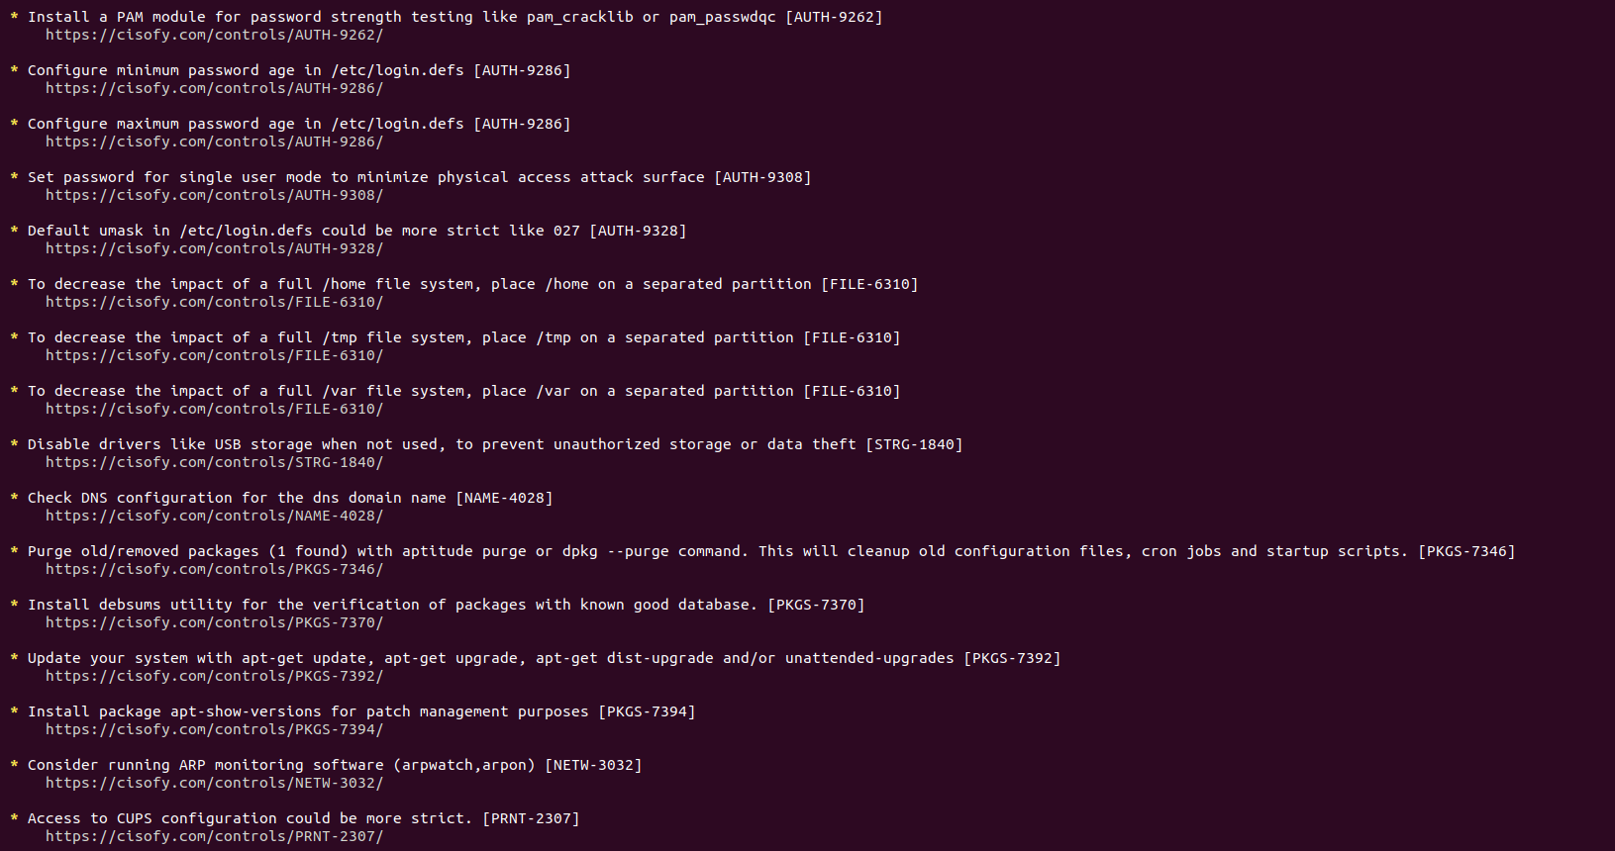

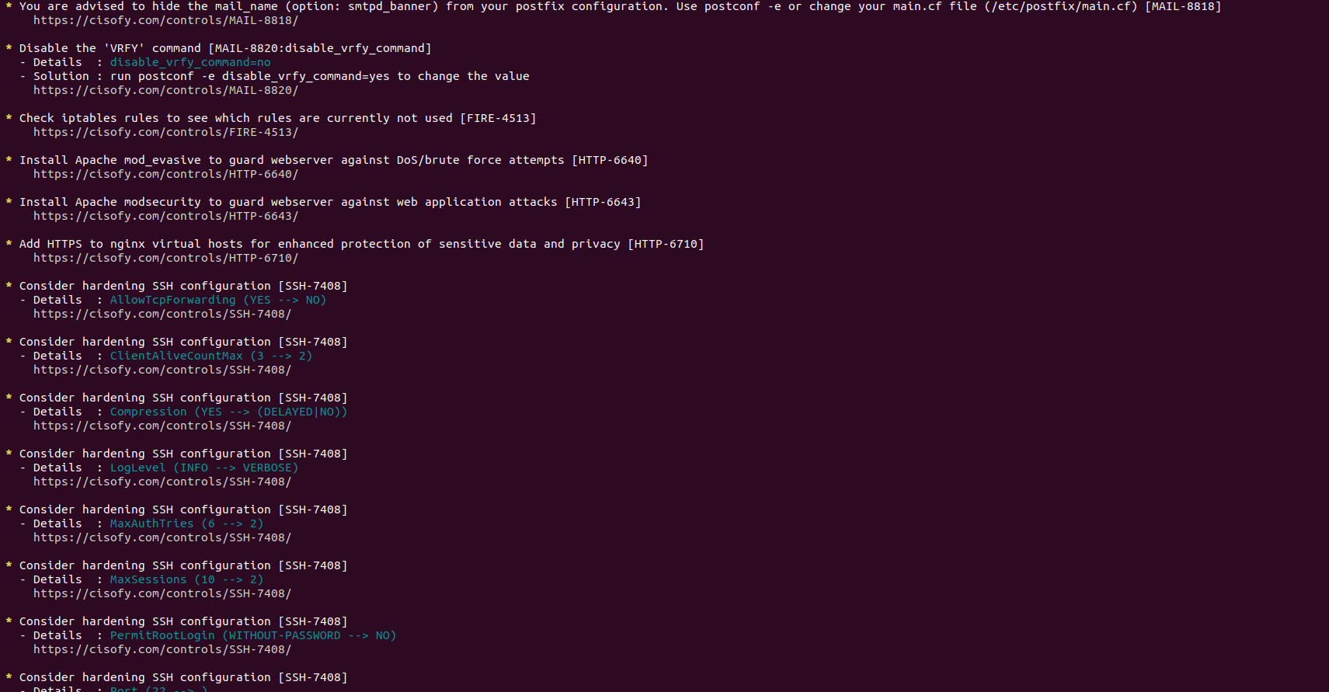

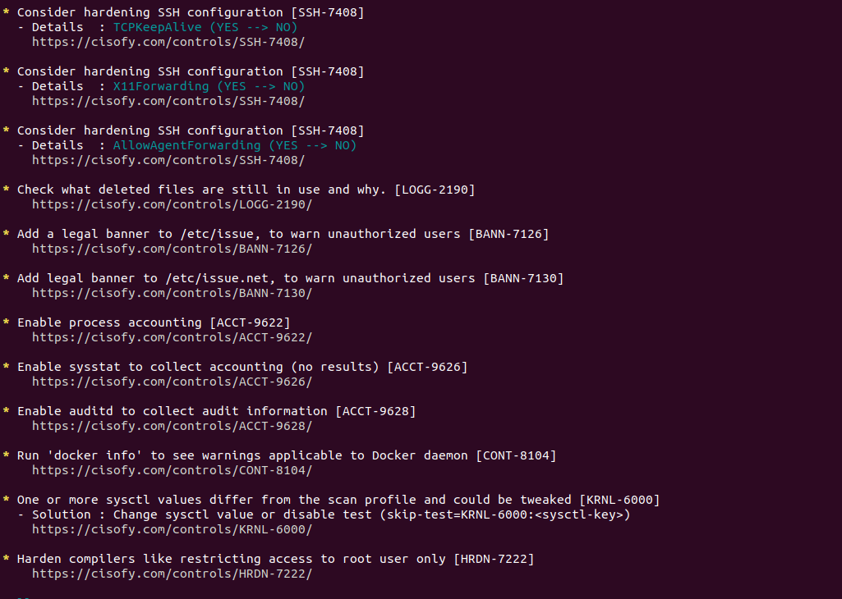

**### Bonus**

1. Command to install chkrootkit:

2. Command to see documentation and instructions:

3. Command to run expert mode:

4. Provide a report from the chrootkit output on what can be done to harden the system.

- Screenshot of end of sample output: